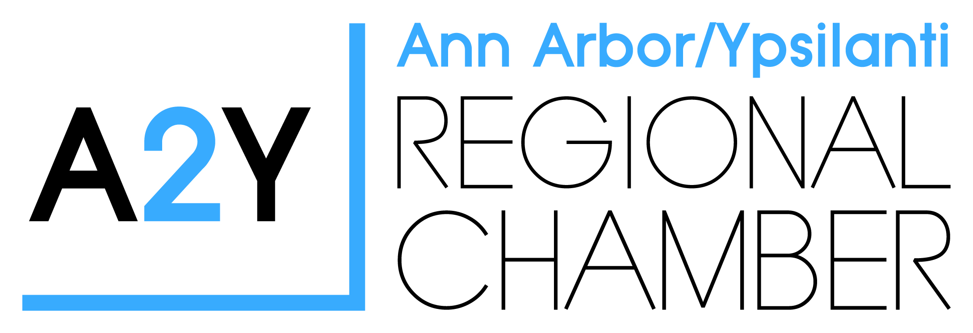

A2Y Ann Arbor/Ypsilanti
Regional Chamber
115 W Huron Street
Ann Arbor, MI 48104
Press Release
Katie Jones
Director of Marketing & Events
Phone: (734) 214-0105
Email: Katie@a2ychamber.org

FOR IMMEDIATE RELEASE

A2Y Chamber is on the Move – to Better Serve You

This fall, the Ann Arbor/Ypsilanti Regional Chamber will be relocating to the Atria Park Business Center, 2010 Hogback Road, Suite 4, Ann Arbor, Michigan 48105, to better serve members, business owners, and the Washtenaw community. The relocation to a centrally located site will provide easier access for members and put a spotlight on the revitalization of the Washtenaw corridor.

The Ann Arbor Chamber took occupancy of the offices on Main Street, in Ann Arbor, in 2007, before the merger of the Ann Arbor and Ypsilanti Chamber, which occurred in 2010. “We love being located in downtown Ann Arbor and experiencing the vibrant energy of Main Street, however, we think we would better serve our members if we were centrally located between the two communities, since we are now a regional chamber,” offered Diane Keller, President of the Ann Arbor/Ypsilanti Regional Chamber.

Mike Manchester, Chairman of the Ann Arbor/Ypsilanti Regional Chamber Board of Directors shared, “When we set to the task of locating a new office, we asked our team what words they would use to describe the ideal member service environment and we heard – collaborative, innovative, central, welcoming, and positive. We feel that the new Atria location on Hogback will create such an environment.”

“The new location takes us closer to embedding the four pillars of Conscious Capitalism (conscious leadership, stakeholder orientation, conscious culture, and higher purpose) into the heart of the Chamber’s mission, increasing the staff’s ability to inspire, engage and energize stakeholders,” Keller further explained.

The Atria Business Park Center, a seven-building office complex in Ann Arbor, is centrally located between Eastern Michigan University and the University of Michigan. It is nestled between US-23 and Washtenaw – with the entrance just behind Yotsuba Japanese Restaurant & Bar on Hogback. The offices will provide greater flexibility for chamber members and staff.

Katie Jones, Marketing Director for the Ann Arbor/Ypsilanti Regional Chamber, enthusiastically exclaimed, “We have always truly believed that great businesses build great communities and our job is to assist our businesses to be the best they can be and attract new ones to the community. Our new location will provide a collaborative and comfortable arena for businesses to prosper, whether they are a sole entrepreneur or a large corporation.”

The new offices will provide complimentary parking, office meeting space, virtual services, Wi-Fi access, and savings on time for meetings due to the close proximity of the membership base.

“Our members are great contributors to the growth of our area, at both a business and community level,” said Keller. “We are confident the move will make our community stronger than ever before, and confirm our pride that there is no better place in the world to live and work than in the Ann Arbor/Ypsilanti area – our home.”

About The Chamber

The Ann Arbor/Ypsilanti Regional Chamber is a 1,200-member community organization that actively facilitates, educates and advocates on behalf of its business members through their services and programs. The Chamber offers numerous networking opportunities, events, educational seminars, benefits and leadership development. Additionally, they partner with other organizations in the Washtenaw County area to assist in the promotion and growth of the area.

For more information about the relocation or the Chamber, please contact Katie Jones, at 734-214-0105 or Katie@a2ychamber.org.

###

