Laurie Armstrong  Saint Joseph Mercy Health System  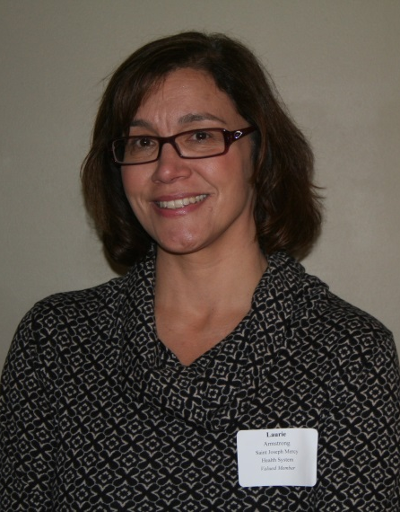 | Joshua Baron  City of Ann Arbor | Chris Bergen  Old National Wealth Management
Melissa Bondy  CTN | Nancy Bowerbank  The Charles Reinhart Company | Tara Bunn  KeyBank
Amanda Carlisle  Washtenaw Housing Alliance | Sheri Chisholm  Junior League Ann Arbor | Kayla Coleman  City of Ann Arbor
Lisa Comben  Eastern Michigan University Foundation | Renae Cranham  University Bank | Jeff Czachowski  The Aspire Group/Eastern Michigan University Athletics
Bill De Groot  Ann Arbor Area Transportation Authority  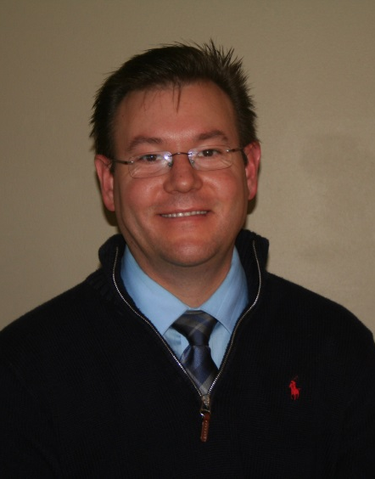 | Marcus English  University of Michigan Credit Union | Suzann Flowers  Washtenaw Area Transportation Study
Emily Fogelsonger  United Way of Washtenaw County  Mary Hancock  Weidmayer Schneider & Raham, CPA | Kristin Gapske  Washtenaw Community College  Kristal Harris  University Bank | Alex Gossage  Ann Arbor Center for Independent Living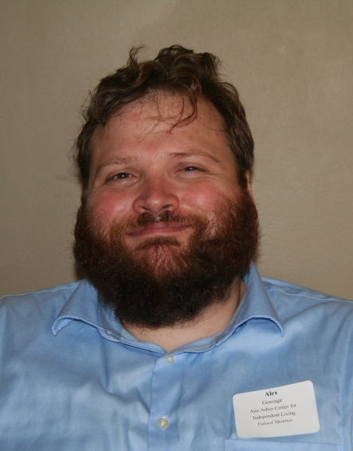  Jon Hradsky  City of Ann Arbor
Kate Krauss  Fair Food Network | Christine Liphardt  UTEC | Spencer Marr  Sandler Training
KJ Miller  Dickinson Wright | Eleanor Moore  Univeristy of Michigan Credit Union | Kristy Myer  Rehmann Robson
John Newman  The Back Office Studio | George Nowsch  Hampton Inn & Suites / Wyndham Garden | Megan O'Connell  Toyota
Dan Pawlak  Washtenaw Federal Credit Union | Alex Perlman  Oxford Companies | Ian Phillips  Miller & Associates
Andy Piper  Piper Partner Real Estate Team | John Rathje  Concordia University Ann Arbor
Keith Russeau  The Collaborative | Pete Sanderson  Washtenaw County Parks & Recreation | A.J. Scheidt  Hylant  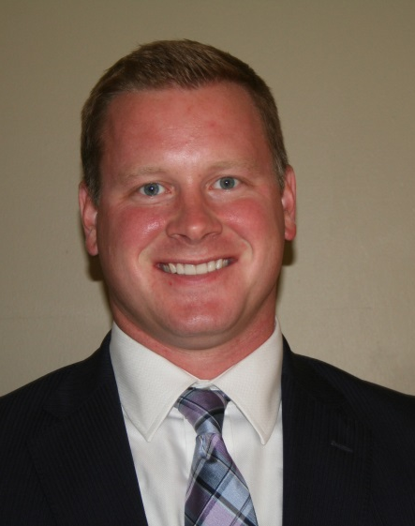
David Smith  Washtenaw County | Bruce Smith  Spence Brothers | John Spidel  OSB Community Bank
Melissa Stricherz  Boy Scouts of America | Jodi Trisdale  A.R. Brouwer Company | Anne Warrow  City of Ann Arbor
Heidi Wegmueller  IMG College | Laura Welsh  Spectrum Printers

