2.0

Assessment | Development | Influence
- at home, at work and in the community
Leadership 2.0 is ideal for current or future leaders seeking insight into their personal leadership style and enhancing their leadership skills, learning about components of leadership, identifying and assessing talent, and preparing talent for the future.

Assessment

Under the guidance of an organizational develop- ment professional, assessment tools will be utilized to provide attendees with a self-assessment of their individual leadership styles. Further discussion focuses on how different styles affect the success of an organization and how those styles are in turn affected by company culture, type of business, and growth stage of a business. Local leaders will discuss real-life experiences in utilizing their leadership styles to grow their businesses, and the successful and not-so-successful experiences in their growth as leaders.

Development

Monthly sessions will cover the primary components of leadership including assessment of organization talent, performance management, development and integration of talent, effective training, succession planning, organizational culture and its impact on employees and community, as well as crisis/change management. Each session will include hands-on exercises and panel discussions with business leaders in the community.

Access

Each session will be facilitated by an experienced organizational development and or human resourc- es professional. Attendees will have the opportunity to learn from successful leaders in the community and explore how the experiences of these leaders may or may not relate to the present or future challenges for each attendee.

Influence

Leadership 2.0’s curriculum delivers knowledge critical to enhancing your professional career and current or future role as a leader in the business com- munity. Beginning at the vital day-and-half-retreat, you will develop a broad network of relationships that carry on long after the program ends. Combining your improved leadership skills with new associates will allow you to better represent your business in the community.

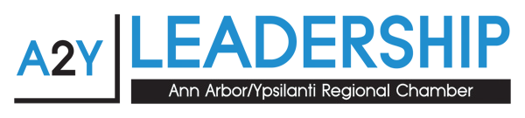

Applications, program information, costs and a class schedule are available at www.a2ychamber.org
or by contacting Barbara Davenport at 734.214.0104 or barbara@a2ychamber.org

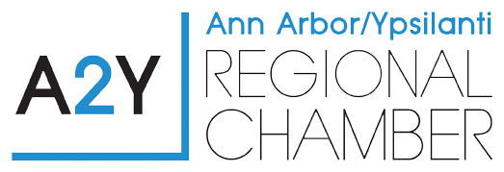
2.0 Class Schedule
2.0

Retreat: January 23, 2018 - full day, January 24, 2018 - half day “Know Yourself (Your Leadership Style)” – Leadership Assessment. Self-assessment of all participants and discussion on leadership styles and case studies of successful and unsuccessful leadership.

February 28, 2018
“Know Your Talent” – Assessment of Talent.
Assessment of talent to maximize effectiveness realized by getting people into right jobs. Discussion on position competencies, leadership potential for future higher level work, readiness for next level positions, and succession planning.

March 28, 2018
“Know Your Talent” – Leadership and Leadership Development.
How to develop effective leadership skills. Preparation of personnel for future leadership positions/roles. Getting employees in the pipeline to meet future strategic planning needs. Tools and strategies to develop talent and build bench strength.

April 25, 2018
“Know Your Talent” – Performance Management.
Integration of annual performance goals with the organization’s strategic plan. Differentiating annual performance goals from positional competency development goals.

May 23, 2018
“You as a Leader” – Crisis Management and Change Management. Leading and promoting successful change within the organization in response to external and internal conditions, and pro-actively creating a dynamic organization.

June 6, 2018
“You as a Leader” – Ethics and Integrity.
Graduation – Participants will graduate upon completion of Ethics and Integrity.
Graduation ceremonies will occur toward the end of this final day.

